IST Assignment-10

Apply following constraints at the time of table creation.

1. Create table **dept**

Dept_id number (primary key)

Dept_name varchar2(not null)

Manager_id number()

Location_id number()

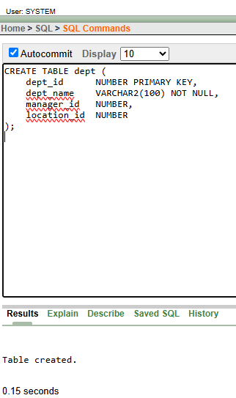

Create table **emp**

Emp_id number()

Last_name varchar2(not null)

Email varchar2(unique)

Salary number(check salary>10000)

Department_id (foreign key references dept_id column in dept table)

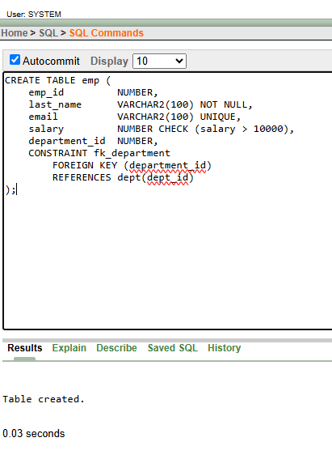

1. Create EMP1 table

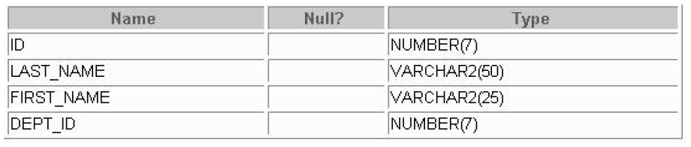

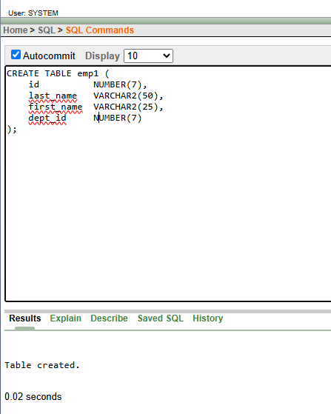

1. Add a table level PRIMARY KEY constraint to the EMP1 table on the ID column. The constraint should be named at creation with name *my_emp1_id_pk.*

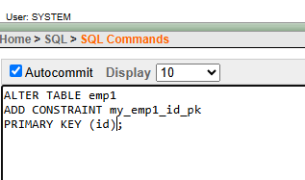

1. Apply NOT NULL constraint on LAST_NAME column.

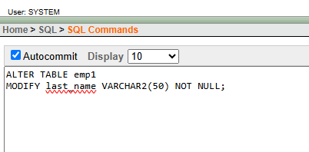

1. Add unique constraint on FIRST_NAME column.

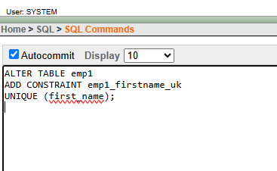

1. Add salary column to the EMP1 table with check constraint that allows salary greater than 20000.

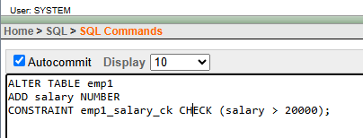

1. List down all the constraints applied on table EMP1.

select * from user_constraints where table_name='EMP1';

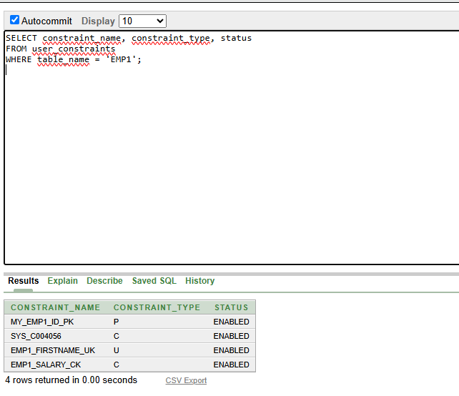

1. Drop Primary key Constraint from EMP1 table.

